Ideation Phase
Define the Problem Statements

Date | 31 January 2025
Team ID | LTVIP2026TMIDS86052
Project Name | Smart Sorting: Transfer Learning for Identifying Rotten Fruits and Vegetable
Maximum Marks | 2 Marks

Customer Problem Statement Template:

Example:

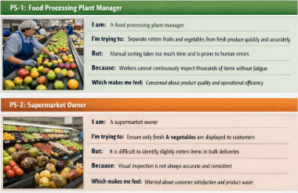

Problem Statement (PS) | I am (Customer) | I’m trying to | But | Because | Which makes me feel
PS-1 | A food processing plant manager | Separate rotten fruits and vegetables from fresh produce quickly and accurately | Manual sorting takes too much time and is prone to human errors | Workers cannot continuously inspect thousands of items without fatigue | Concerned about product quality and operational efficiency
PS-2 | A supermarket owner | Ensure only fresh fruits and vegetables are displayed to customers | It is difficult to identify slightly rotten items during bulk delivery | Visual inspection is not always accurate and consistent | Worried about customer satisfaction and product waste

